1. Configuring cygwin
   * Download cygwin setup from [here](https://cygwin.com/setup-x86_64.exe).
   * Run the set up.
   * Click on Next.
   * Choose the download Source as the internet and click on Next.
   * Choose the root installation directory as the recommended directory.
   * Click on Next.
   * Local package directory must be already recommended. Click on Next.
   * Use the System Proxy Settings and click on Next.
   * Choose a mirror for downloading. Choose any one from the list.
   * And click on Next.
   * In the search box search for the following and select all the related stuff to download.
     + OpenSSH,
     + tcp_wrappers,
     + diffutils [this should be pre-selected],
     + zlib
   * Click on Next.
   * And again Next.
   * The set up will be downloading the required files.
   * After it downloads click Finish.
   * The setup creates a shortcut to the cygwin terminal on the desktop.
   * Run the terminal as administrator.
   * The command **ssh-host-config**.
   * Enter yes in all the inputs except:
   * When it asks for the value of CYGWIN for the daemon enter an empty value
     + When it asks to use a different user name for registered services, enter no
     + When it asks for the password, enter anything to create a password.
   * After entering the password, your ssh host account has been created
   * Enter net start sshd to start the sshd service.
   * To test try connecting with your own system by entering **ssh localhost.**
   * Enter yes, and then the password for the system.
   * If it shows no error and commands executes successfully, the ssh host config is complete.
2. Configuring hadoop
   * Download hadoop from [here](http://www-eu.apache.org/dist/hadoop/common/hadoop-1.2.1/hadoop-1.2.1-bin.tar.gz).
   * Extract the compressed file and paste it to the following location: **‘C:\cygwin64\usr\local\’**.
   * Now open the file **‘hadoop1.2.1\conf\hadoop-env.sh’** and make the following changes:
     + Uncomment this line (line number 9) and enter the value of JAVA_HOME as per your system.
       - export JAVA_HOME=C:/Program Files/Java/jdk-9.0.1
       - Make sure it includes forward slash and not back slash
       - Save the file and exit.
     + Open ‘**hadoop1.2.1\conf\core-site.xml’** file and add below code.
       - <configuration>  
         <property>  
         <name>fs.default.name</name>  
         <value>hdfs://localhost:50000</value>  
         </property>  
         </configuration>

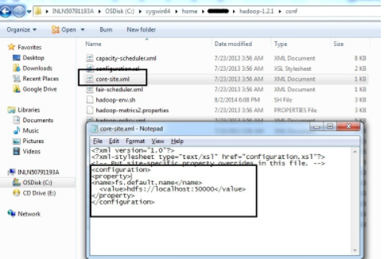

* Open **mapred -site.xml** file in the same folder and add below code

<configuration>

<property>

<name>mapred.job.tracker</name>

<value>localhost:50001</value>

</property>

</configuration>

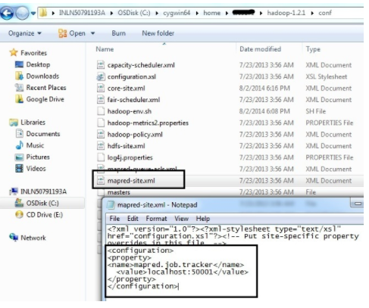

* Open **hdfs -site.xml** file and add below code.Change the USER_FOLDER_NAME in the below code as per your your user name.

<configuration>

<property>

<name>dfs.data.dir</name>

<value>/home/USER_FOLDER_NAME/hadoop-dir/datadir</value>

</property>

<property>

<name>dfs.name.dir</name>

<value>/home/USER_FOLDER_NAME/hadoop-dir/namedir</value>

</property>

</configuration>

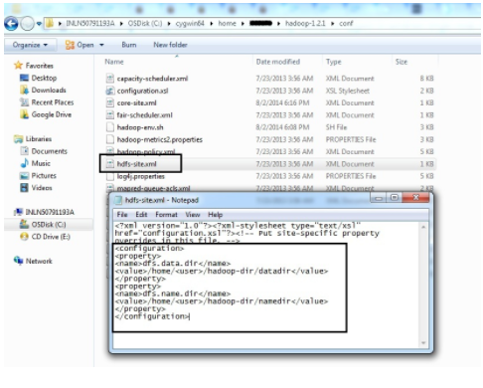

If you don’t know your username, check it in the folder **‘C:\cygwin64\home\’**.

* Now change the current directory to **‘/usr/local/hadoop-1.2.1/bin’**
* Enter the command ‘**./hadoop namenode -format**’.
* Now enter **‘./start-all.sh’.**
* It will start off the hadoop services.
* To stop hadoop we can use ‘**./stop-all.sh’.**

1. Configuring HBase
   * Download HBase-bin from [here](http://www-eu.apache.org/dist/hbase/1.1.13/hbase-1.1.13-bin.tar.gz).
   * Also download Hbase-src from [here.](http://www-eu.apache.org/dist/hbase/1.1.13/hbase-1.1.13-src.tar.gz)
   * Extract the compressed files.
   * Now from the HBase-bin folder, copy the lib folder and paste it into the HBase-src folder.
   * Now copy the HBase folder to the same folder where hadoop was copied.
   * Open the file ‘**./conf/hbase-env.sh’.**
   * Change the Java Home here again like we did in Hadoop.
   * Also, change the line **‘export HBASE_CLASSPATH’** as

export HBASE_CLASSPATH=**HBase directory**/lib/zookeeper-3.4.3.jar

* + Now traverse to the hbase directory in the cygwin terminal and enter the command **‘./bin/start-hbase.sh’**.
  + HBase is up and running.